|  |  |
| --- | --- |
| **Canon EOS R5 (Body Only)**  Máy ảnh Canon EOS R5 (Body Only)  Canon EOS R5 1 Canon EOS R5 2 Canon EOS R5 5 Canon EOS R5 3 | **Featured information:**   * 45MP full-frame CMOS sensor * Continuous shooting at 12 fps with mechanical shutter, 20 fps with electronic shutter * 5-axis image stabilization (IBIS) * Video recording 8K 30 fps, 4K 120 fps, 4K 60 fps   Price: 3000$  **Specifications:**   * **Sensor Format:** Full-Frame (1x Crop Factor) * **Resolution:** 47.1 megapixels * **Size photo:** 8192 x 5464 * **Image Proportions:** 1:1, 3:2, 4:3, 16:9 * **Sensor Type:** CMOS * **Image Format:** JPEG, Raw * **Anti-Vibration:** Sensor-Shift, 5-Axis * **Lens Mount:** Canon RF |

**Description:**

#### **Canon EOS R5 - 45MP Full-frame sensor & DIGIC X image processing chip**

Canon R5 owns a 45MP Full-frame sensor designed and developed by Canon itself, providing high resolution images and videos. Combined with the DIGIC X processor that previously appeared on the 1DX III, the Canon EOS R5 can provide fast data reading and processing capabilities.

#### **Some design features of the Canon EOS R5**

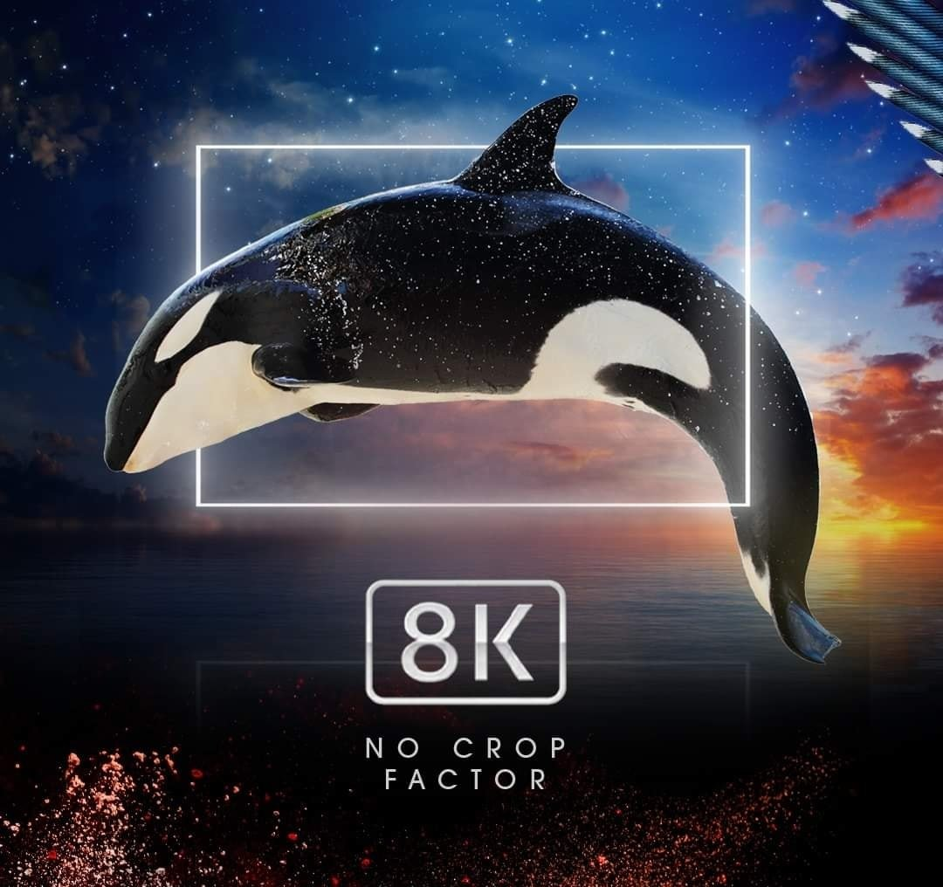

The Canon EOS R5 uses a second generation Dual Pixel CMOS focusing system with 1053 selectable focus points, covering 100% of the frame and providing fast, smooth focusing performance. Touch AF is also an advantage, this feature allows users to change the focus point by touching directly on the touch screen.

